EXPERIMENT -2
AIM: Shell Scripting

A Shell is a command-line interpreter that acts as an interface between the user and the operating system. It accepts commands from the user, sends them to the operating system for execution, and displays the output.

Example
When the user enters the command:

date

The shell sends this command to the operating system, which retrieves the current date and displays it on the screen.

A Shell Script is a text file containing a sequence of Linux commands that are executed automatically by the shell.

Instead of typing commands one by one, they can be written in a single script file and executed together.

Advantages of Shell Scripting
- Automates repetitive tasks
- Saves time and effort
- Reduces human errors
- Easy to write and maintain
- Useful for system administration and automation

- To write a shell script to add two numbers entered by the user.
Create a new file: nano addition.sh
Write the following program:
#!/bin/bash
echo "Enter first number:"
read num1
echo "Enter second number:"
read num2
sum=$((num1 + num2))
echo "Sum = $sum"
Save the file:
- Ctrl + O
- Enter
- Ctrl + X
Run the program:
chmod +x addition.sh
./addition.sh

Sample Output:
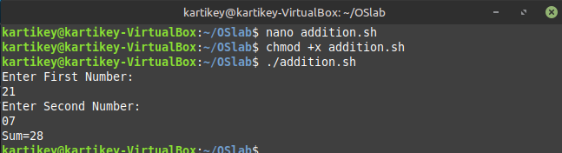

- To write a shell script to find Even or Odd.
#!/bin/bash

echo "Enter a number:"
read n

if [ $((n%2)) -eq 0 ]
then
echo "Even"
else
echo "Odd"
fi

Sample Output :
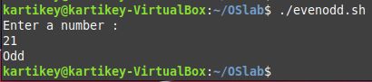

- To write a shell script to find largest of Two Numbers
#!/bin/bash

echo "Enter first number:"
read a

echo "Enter second number:"
read b

if [ $a -gt $b ]
then
echo "$a is greater"
else
echo "$b is greater"
fi

Sample Output:
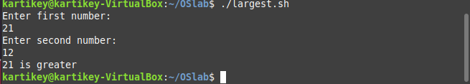

- To write a shell script to find Factorial of a number.
#!/bin/bash

echo "Enter a number:"
read n

fact=1

for ((i=1;i<=n;i++))
do
fact=$((fact*i))
done

echo "Factorial = $fact"

Sample Output:
